2.26: a) x₀ < 0, v_{0x} < 0, a_{x} < 0

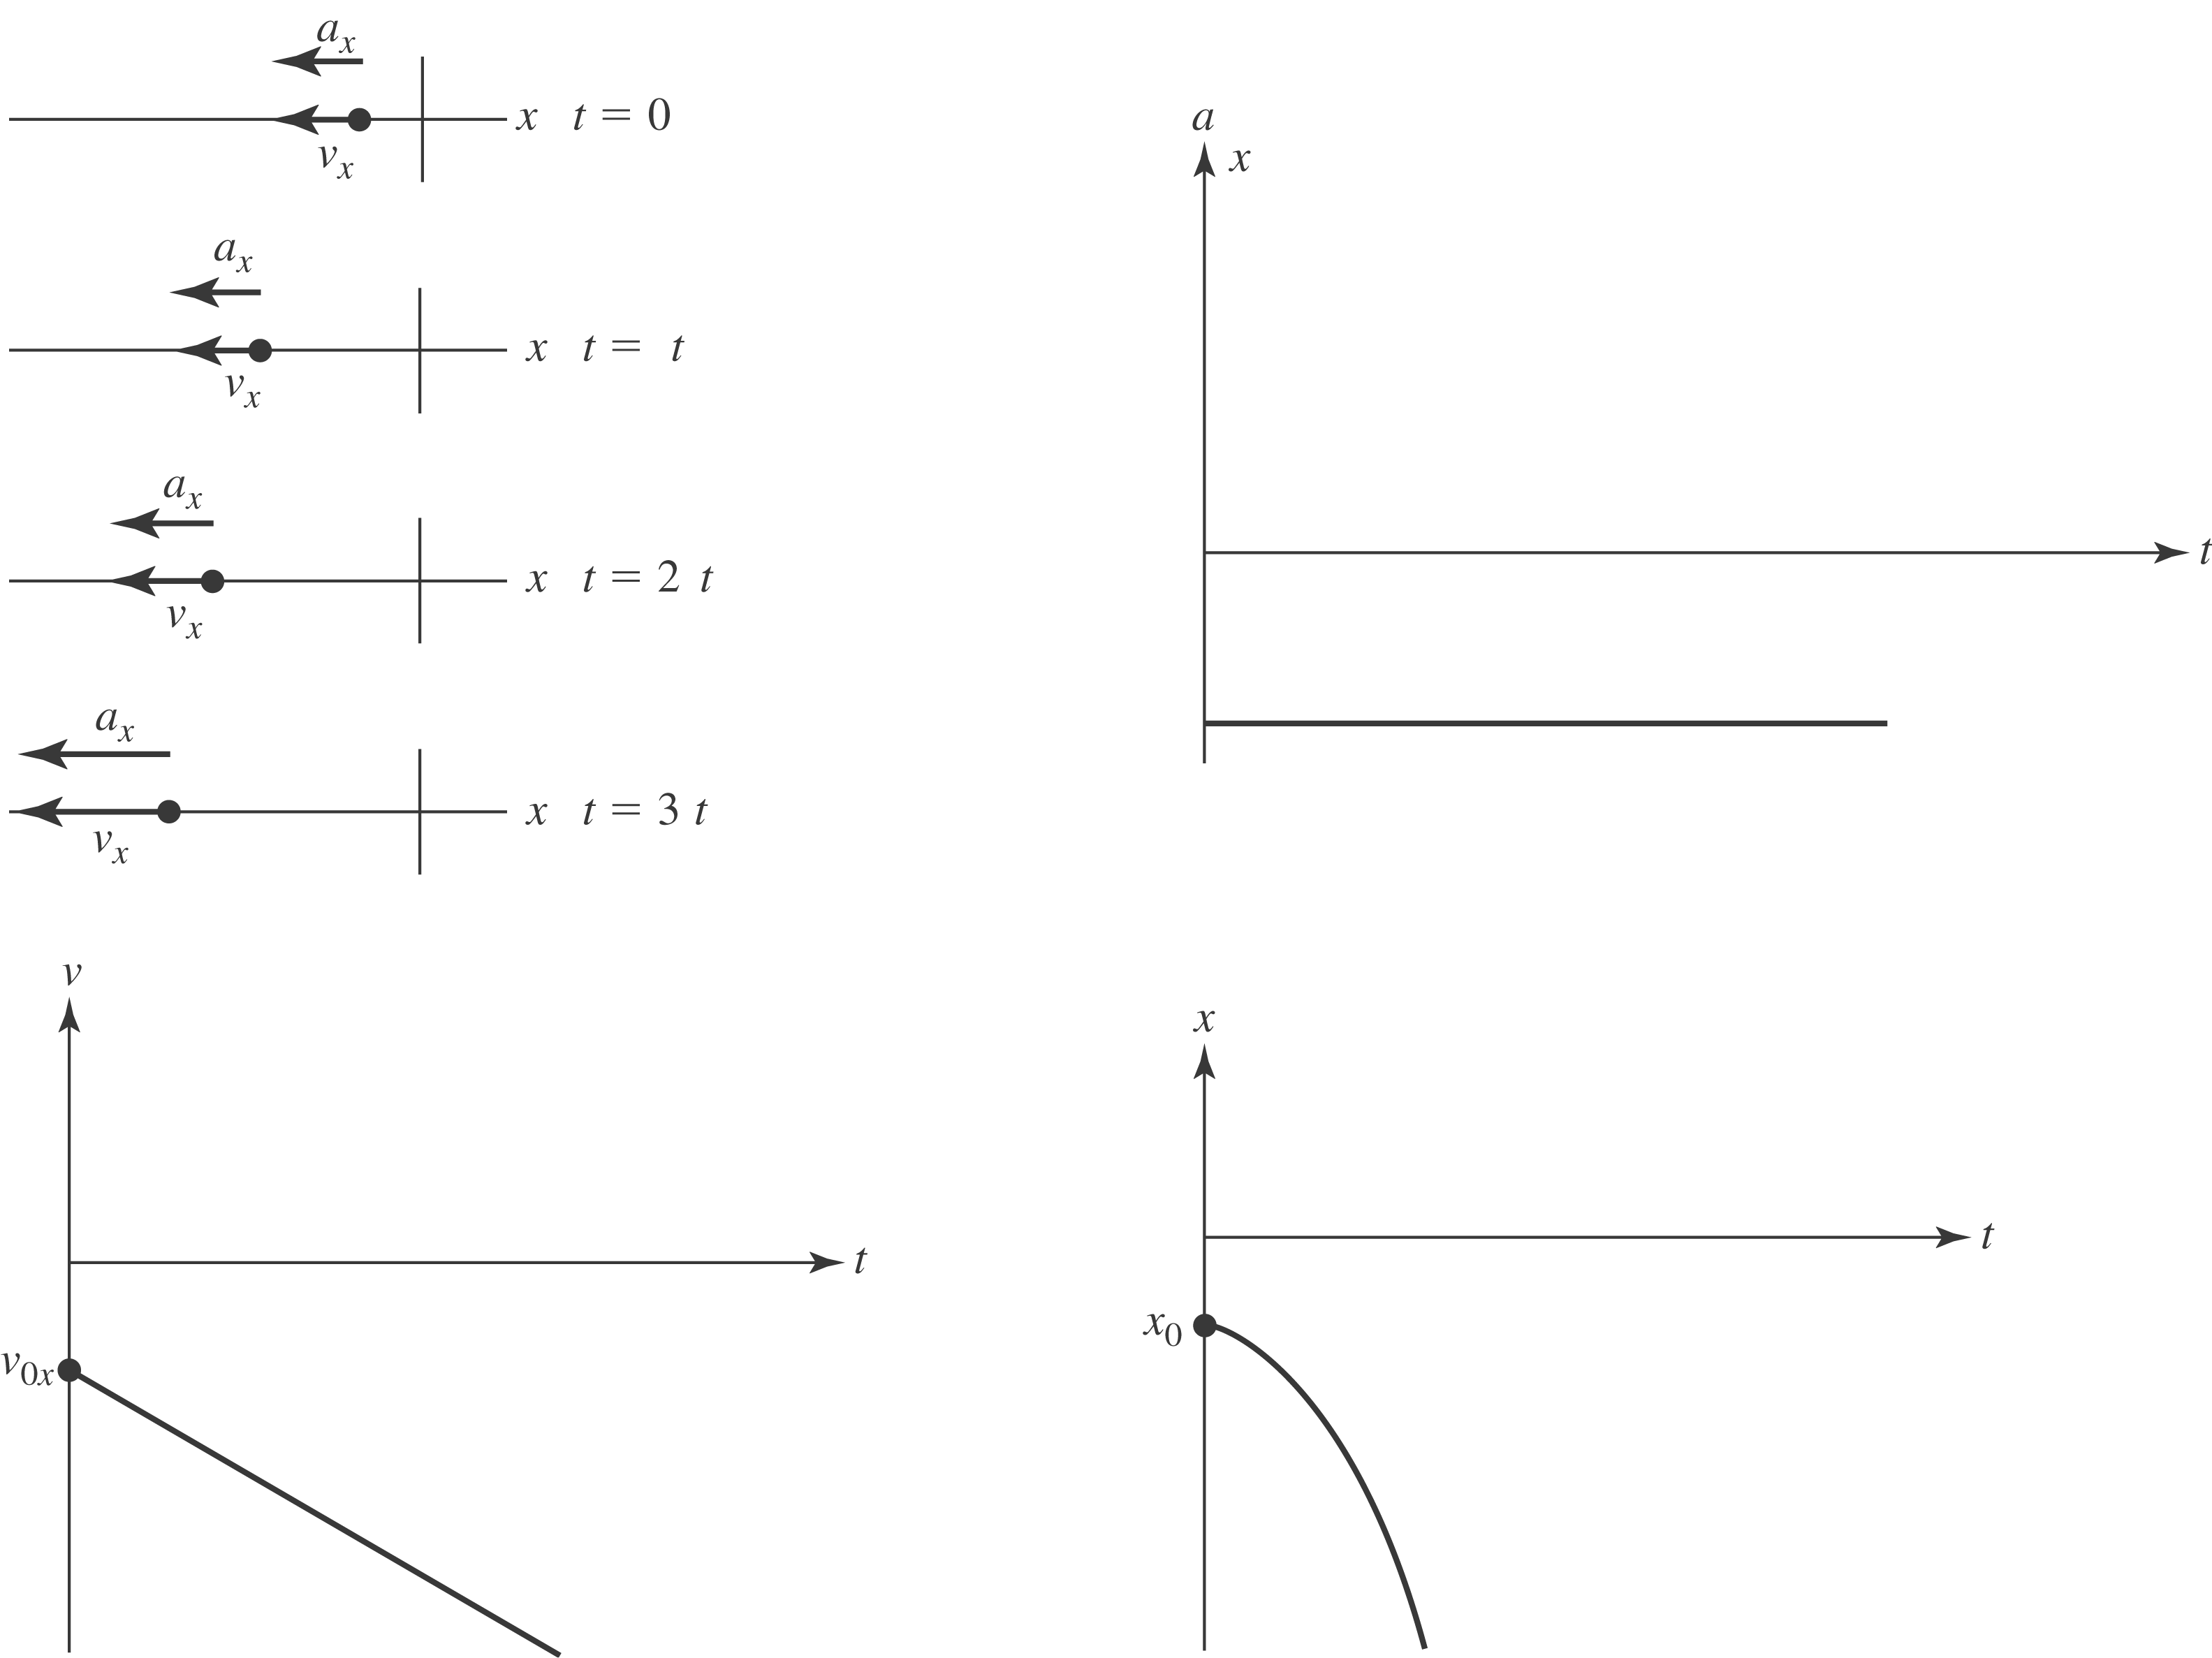

- x₀ > 0, v_{0x} < 0, a_{x} > 0

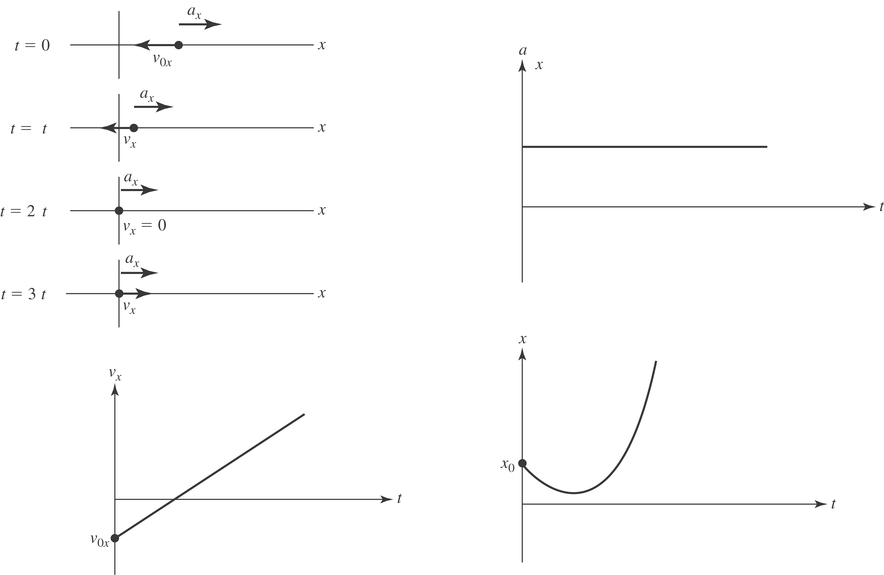

- x₀ > 0, v_{0x} > 0, a_{x} < 0

